**WEEK-1:**

**Program-1**:

***Aim***:- Downloading and installing Java software

**Procedure**:-

Step1:- Open Google chrome and search for java downloads

Step2:- Download java development kit(JDK) from oracle official website.

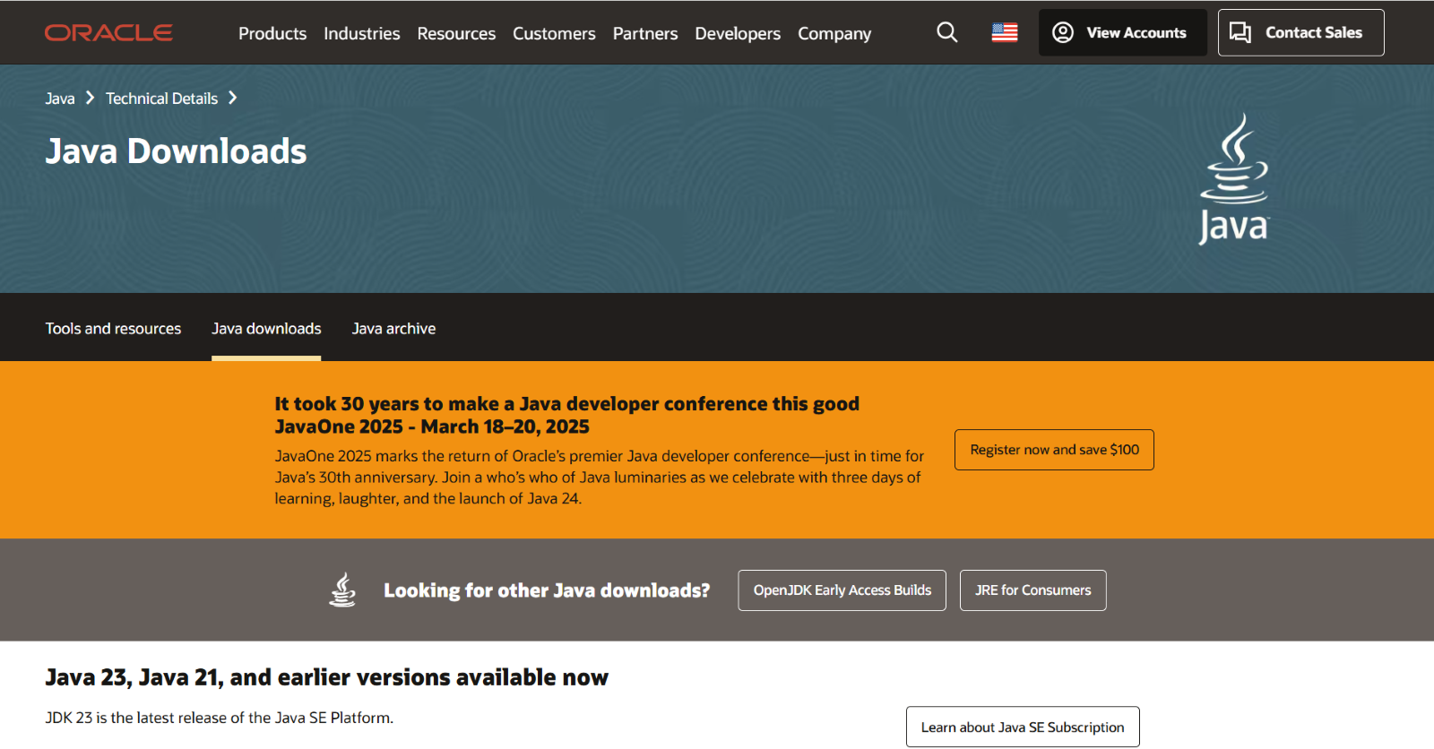

Step3:- Download JDK21.0.6 x64 Installer Windows version.

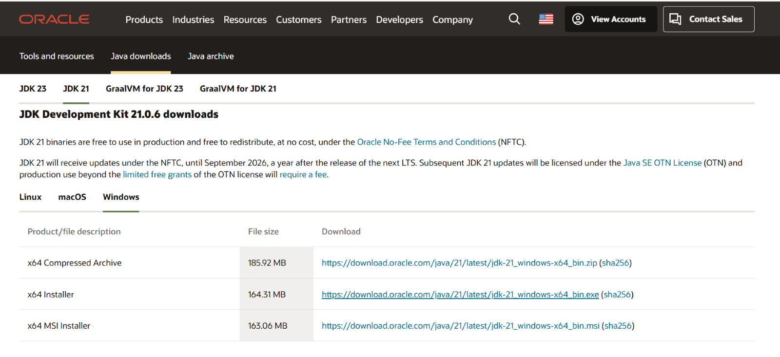

Step-4:-Click on the link provided to download. After downloading install the software into your device.

Step-5:- After installation we need to set environment set variable path of installation.

Step-6:- To set variable path open files then windows c file then program files then java then jdk-21. Select bin and copy the path.

Step-7:- Now open environmental variables then open system variable. Here we have to paste the copied path in path variable.

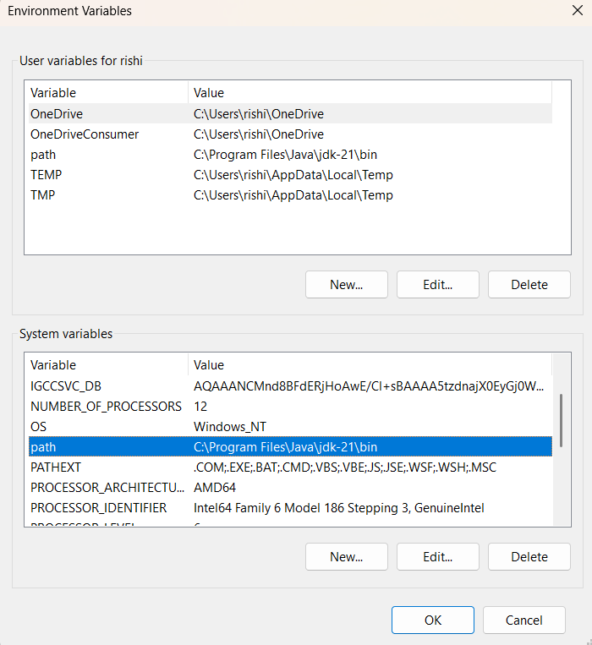

Step-8:- Now java software is installed in your device. Now to check the installed version. Open command prompt

Step-9:-in command prompt type java –version then click on enter

Step-10:-The version is displayed

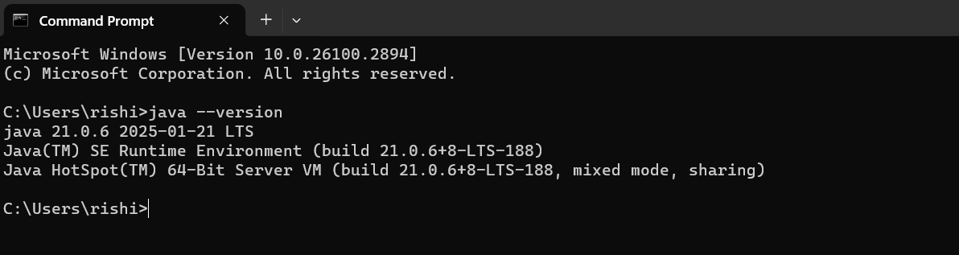**PROGRAM-2:**

**AIM**: Write a java program to print the message "Welcome to java programming”

**INPUT**:

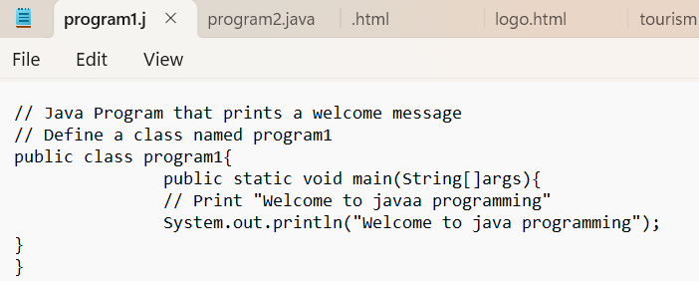

**OUTPUT:**

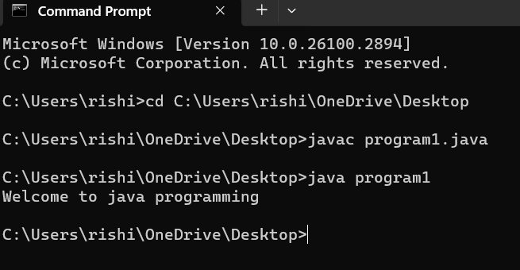

**PROGRAM-3:**

**AIM:**- Write a java program that prints name, roll number, section of a student

**INPUT:**

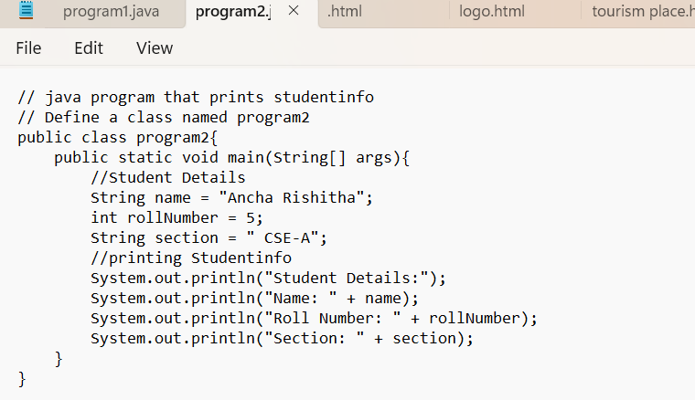

**OUTPUT**:

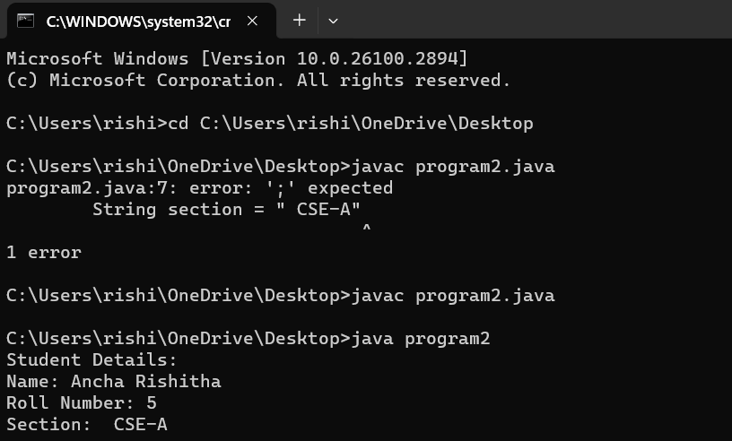

**ERRORS:**

|  |  |  |
| --- | --- | --- |
| S.NO | ERROR MESSAGE | ERROR RECTIFICATION |
| 1. | ‘;’ expected | Placing ‘;’ symbol |

**Week-2:**

**PROGRAM-1:**

**Aim**: To write a java program for calculating area of rectangle.

Input Code:

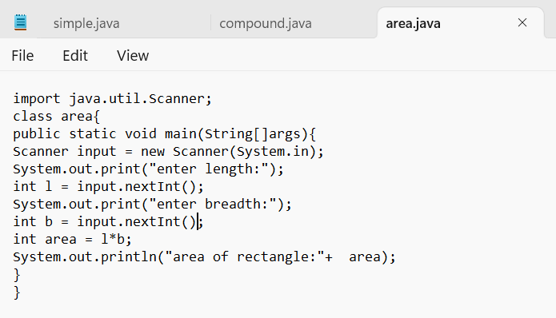

Output:

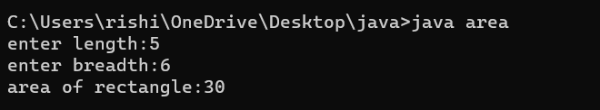

ERRORS:

|  |  |  |
| --- | --- | --- |
| S.NO | ERROR MESSAGE | ERROR RECTIFICATION |
| 1. | Error:”;” expected | Inserted ; |
| 2. | Error:”string”small letter case sensitive | “String” |

**Steps:**

1.import java.util.Scanner -step to import library.

2. used Scanner library to get input from user in run time.

3. “Scanner input=new Scanner(System.in);”-step to use the scanner .

**PROGRAM-2:**

Aim:To write a java program for converting Celsius to Fahrenheit.

Code:

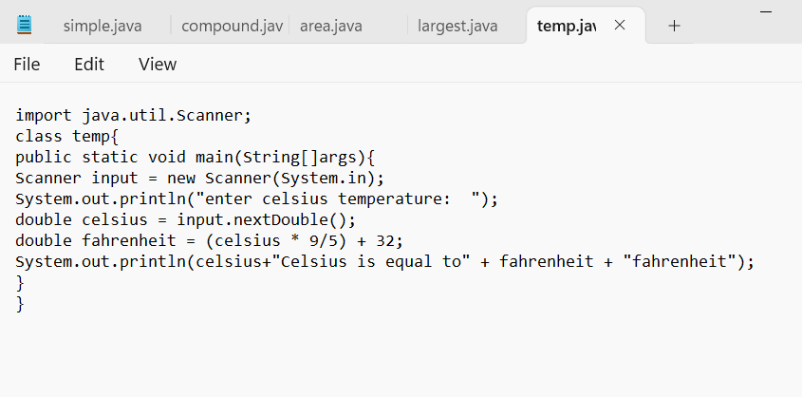

Output:

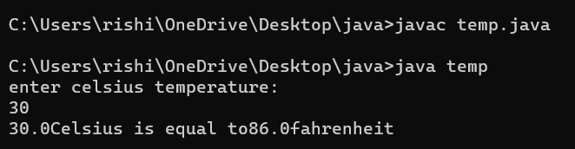

Errors:

|  |  |  |
| --- | --- | --- |
| S.NO | ERROR MESSAGE | ERROR RECTIFICATION |
| 1. | Error:Temp “file not found” | “temp” |
| 2. | Error: scanner input “Capital letter case sensitive” | “Scanner input” |

**Steps:**

1.import java.util.Scanner -step to import library.

2. used Scanner library to get input from user in run time.

3. “Scanner input=new Scanner(System.in);”-step to use the scanner .

**PROGRAM-3:**

**Aim**: To write a java program for converting Fahrenheit to Celsius.

Code:

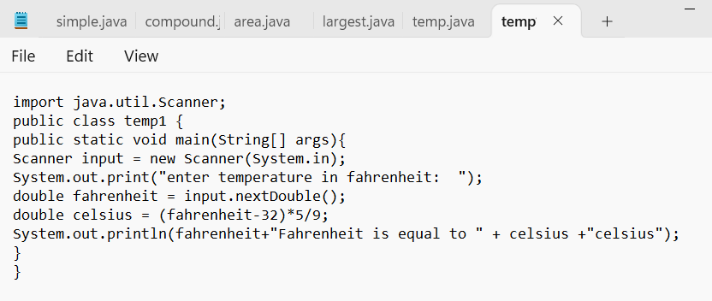

Output:

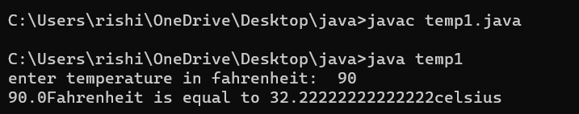

Errors:

|  |  |  |
| --- | --- | --- |
| S.no | Error message | Error Rectification |
| 1. | Error:File not found | “temp1 “ |
| 2. | Error:”;” unexpected | Inserted ; |
| 3. | Error: incorrect formula | Rewrite formula |

STEPS:

1.import java.util.Scanner -step to import library.

2. used Scanner library to get input from user in run time.

3. “Scanner input=new Scanner(System.in);”-step to use the scanner .

**PROGRAM-4:-**

**Aim:** To write a java program for calculating simple interest.

Code:

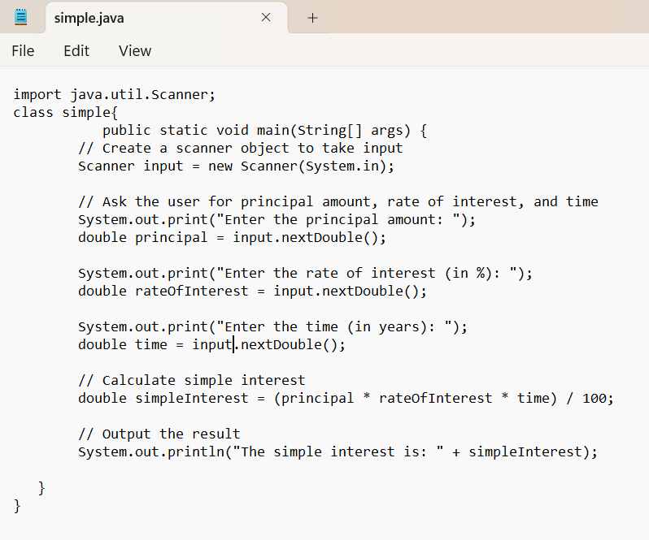

Output:

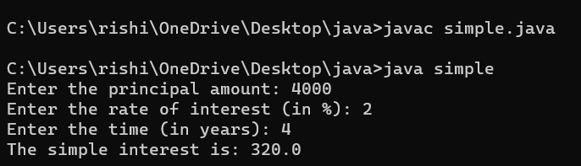

ERROR:

|  |  |  |
| --- | --- | --- |
| S.no | Error Message | Error Rectification |
| 1. | Error: input.nextdouble[] “parenthesis” | “input.nextdouble()” |
| 2. | Error: “Access Modifier for class “ | Public class simple |

STEPS:

1.import java.util.Scanner -step to import library.

2. used Scanner library to get input from user in run time.

3. “Scanner input=new Scanner(System.in);”-step to use the scanner .

**PROGRAM-5:-**

**Aim:** To write a java program for finding largest among 3 numbers using ternary operator.

Input code:

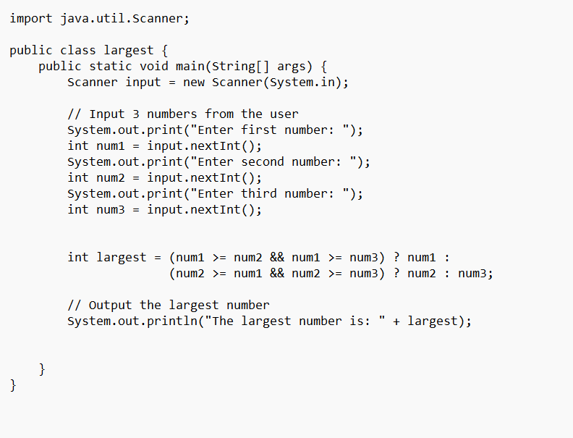

Output:

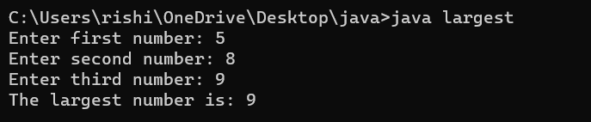

ERROR:

|  |  |  |
| --- | --- | --- |
| S.no | Error Message | Error Rectification |
| 1. | Error: input.nextInt[] “parenthesis” | “input.nextInt()” |
| 2. | Error: “Scanner Object not Closed“ | Placed parenthesis () |

STEPS:

1.import java.util.Scanner -step to import library.

2. used Scanner library to get input from user in run time.

3. “Scanner input=new Scanner(System.in);”-step to use the scanner .

5)Aim: Writing a java program for finding factorial of a number.

Code:

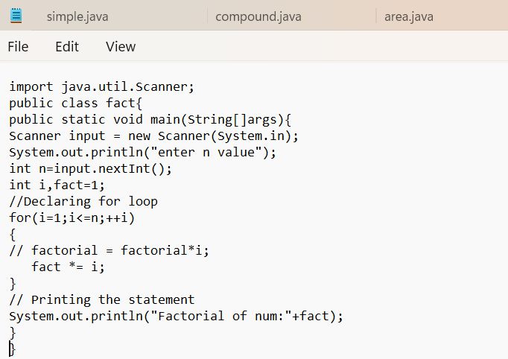  
Output:

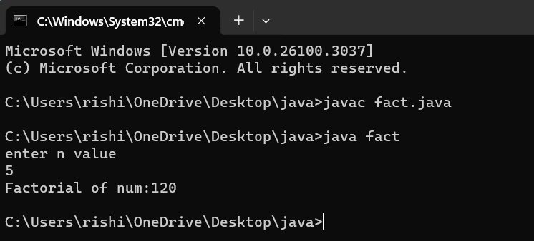

ERROR:

|  |  |  |
| --- | --- | --- |
| S.no | Error Message | Error Rectification |
| 1. | Error: ‘file not found’Fact | ‘fact' |
| 2. | Error: “Variable i not declared properly“ | Declared inside the loop |
| 3. | Error: expected”;” | Inserting ‘;’ |

STEPS:

1.import java.util.Scanner -step to import library.

2. used Scanner library to get input from user in run time.

3. “Scanner input=new Scanner(System.in);”-step to use the scanner .

**Week-3:**

**PROGRAM-1:**

**Aim**: To write a java program that defines a Car class with attributes, a constructor and methods to perform actions like starting,stopping and servicing a car

Input Code:

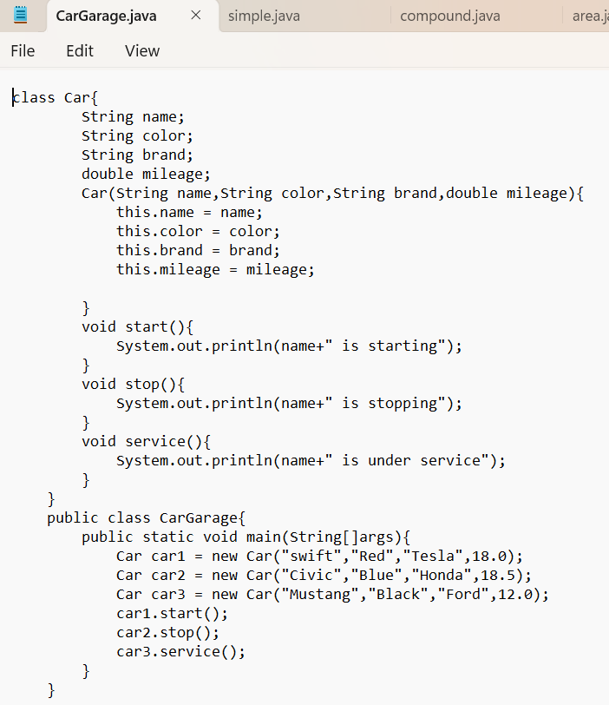

Output:

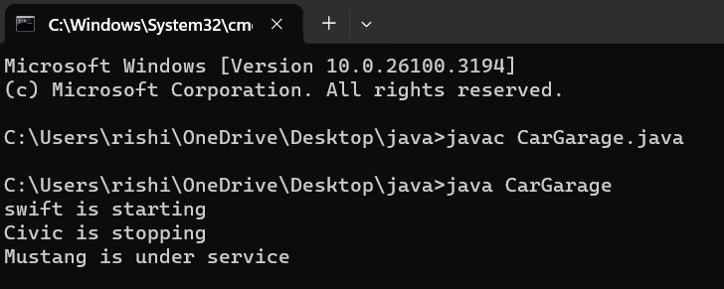

ERROR:

|  |  |  |
| --- | --- | --- |
| S.no | Error Message | Error Rectification |
| 1. | Error: expected () paranthesis | Start() |
| 2. | Error: expected ‘}’ | Placed ‘}’ |

STEPS:

1.Defines a car class with attributed and initializes them using a constructor.

2.Implements start(),stop() and service() methods to print car actions.

3. Creates Car objects and calls their methods to display messages.

**PROGRAM-2:**

**Aim**: To write a java program that allows user to create a bank account,deposit money and withdraw money.

Input Code:

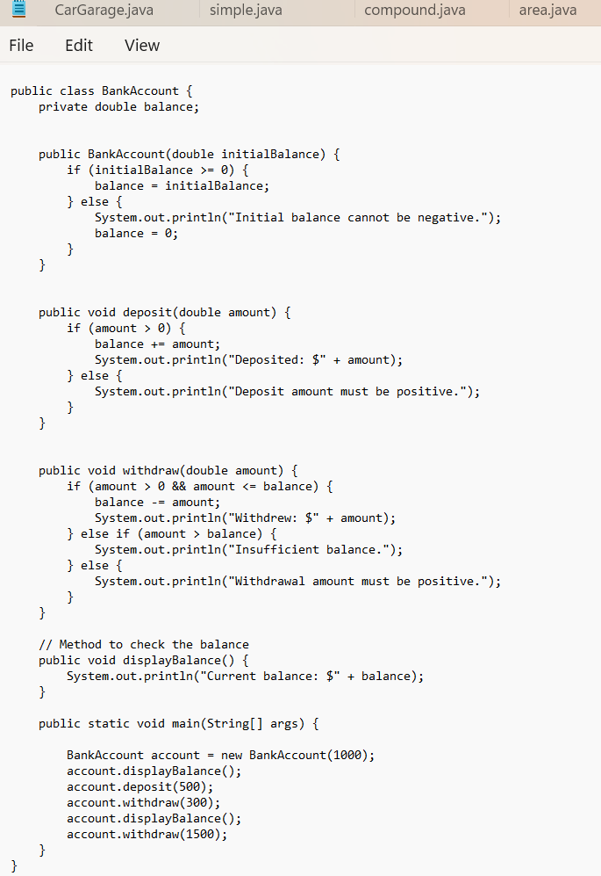

Output:

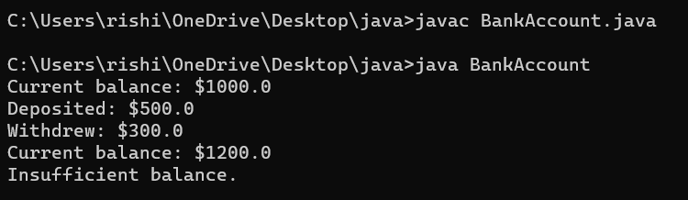

ERROR:

|  |  |  |
| --- | --- | --- |
| S.no | Error Message | Error Rectification |
| 1. | Error: incorrect method call | Inserted () |
| 2. | Error: “;” expected | Placed ‘;’ |

STEPS:

1. Define the BankAccount class with a constructor to initialize the balance.

2. Create deposit(), withdraw(), and displayBalance() methods for account operations.

3. Create a BankAccount object, perform transactions, and display the balance.

**WEEK-4:**

**PROGRAM1:**

AIM:Write a java program that prints the details of the book

CLASS DIAGRAM:

|  |
| --- |
| Book  Attributes  -title: String  - author:String  -yearPublished:int  Methods  + Book(title,author,yearPublished)  +displayDetails():void |

INPUT CODE:

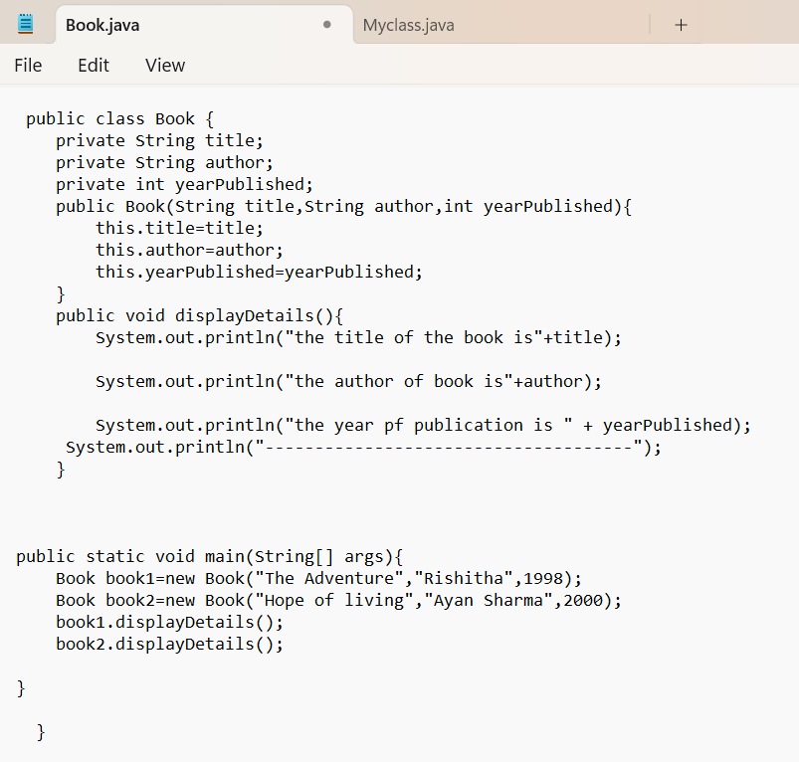

OUTPUT:

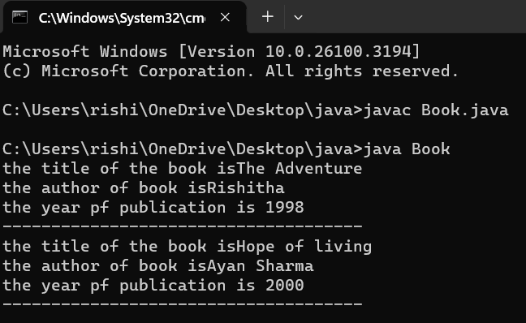

ERROR:

|  |  |  |
| --- | --- | --- |
| S.no | Error Message | Error Rectification |
| 1. | Error: incorrect method call | Inserted () |
| 2. | Error: “;” expected | Placed ‘;’ |

Steps:

1. Create a Book class with attributes (title, author, yearPublished) and a constructor to initialize them.

**2.** Write method (displayDetails())

**3.** Instantiate Book objects in main(), then call the display methods to output their details.

**PROGRAM2**:

AIM:Write a java program that increments the count variable

CLASS DIAGRAM:

|  |  |  |  |  |  |  |  |
| --- | --- | --- | --- | --- | --- | --- | --- |
| |  | | --- | | **MyClass** |  |  | | --- | | **Attributes** |  |  | | --- | | - count: int (static) |  |  | | --- | | - pi: double (final) |  |  | | --- | | **Methods** |  |  | | --- | | + MyClass() |  |  | | --- | | + display(): void | |

INPUT CODE:

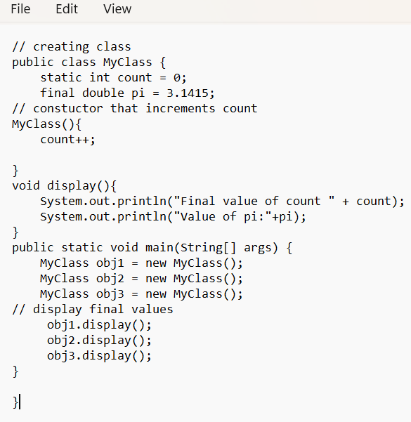

OUTPUT:

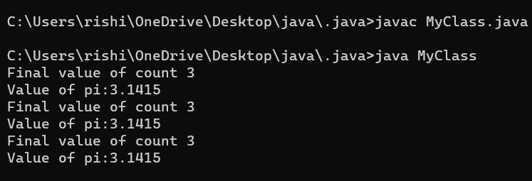

ERROR:

|  |  |  |
| --- | --- | --- |
| S.no | Error Message | Error Rectification |
| 1. | Error: unresolved compilation problem | Removed pi++ |
| 2. | Error: incorrect object name pnj1 | Corrected spelling obj1 |

STEPS:

**1.**Create a MyClass with a static variable count and a final constant pi.

2.The constructor increments count, and display() prints count and pi.

3.Instantiate MyClass objects in main() and call display() to observe count changes.